- Industry Structure
- Vietnam is the second largest market in Southeast Asia (second only to Indonesia), with the huge amount of revenue it has brought in over the last 3 years.
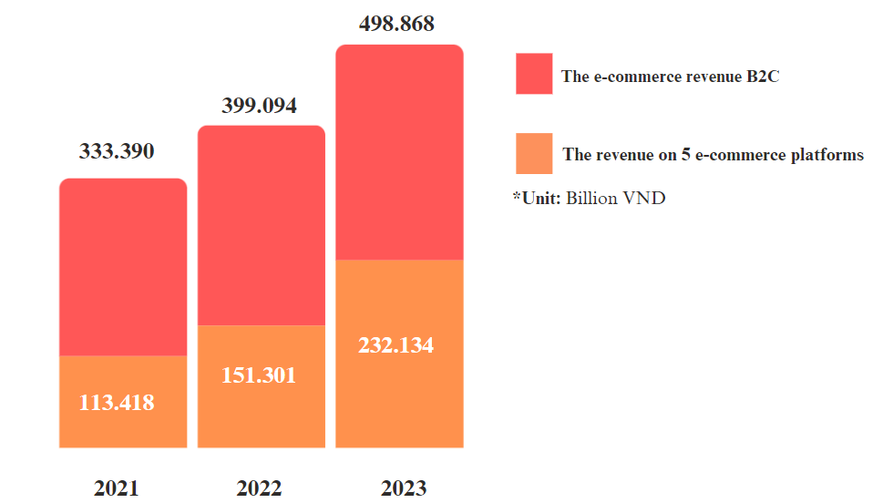
(According to Metric statistics - number of e-commerce platforms)
- In the first 3 months of 2024, the total market share is divided equally to 4 major E-commerce platforms: Shopee, Lazada, Tiki and TikTok Shop.
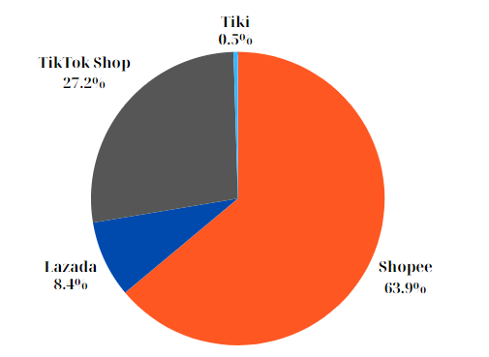
(According to Metric statistics - number of e-commerce platforms)
And Lazada will be the marketplace which we choose to analyze more clearly.
- Field: Lazada is one business operating in the e-commerce space. Some of its main activities include online retail, delivery services, online and direct payments.
- Function of Lazada: B2B2C is Lazada's current business model. This model is an intermediary that helps sellers and buyers buy and sell goods online with each other through the application it provides.
- Size of Lazada: Lazada is the top e-commerce platform in Southeast Asia, with key markets: Vietnam, Indonesia, Thailand, Malaysia, Singapore, and the Philippines. In Vietnam, Lazada has a large scale of operations with revenue of 3.3 billion USD (2023), more than 80 million active users each month with more than 400,000 sellers.
- Competitors: In the Vietnamese market, Shopee is an existing competitor and Lazada's biggest rival on the e-commerce platform. Besides, even though it only appeared recently, Tik Tok Shop is also becoming one of Lazada's competitors.

- Strategy Competitor
Lazada's vision is to accelerate development for Southeast Asia. This vision aims to transform the way people shop and sell online, creating a more inclusive and accessible e-commerce environment, empowering businesses, and sellers to thrive in the digital economy.
With the mission of Bringing the world to Southeast Asia so that Southeast Asian brands can reach international consumers and help to create an ecosystem to "To make it easy for anyone to do business anywhere". Lazada is applying the differentiation strategy well, focusing on providing good customer experience, diverse and quality products/services.
1. Lazada focuses on providing good customer experience:
- Lazada invests in a friendly, easy-to-use web interface and application.
- Lazada provides professional customer service and 24/7 support.
- Lazada develops a safe and convenient payment system.
2. Lazada provides a variety of products from reputable brands:
- Lazada cooperates with many reputable sellers to provide a variety of products to customers. (Lazada develops exclusive services such as Lazada Plus (free shipping, returns), LazMall (genuine goods), Lazada Global (international goods).
- Lazada strictly controls product quality to ensure brand reputation. One of the recent new projects that Lazada has launched is the IPP (Intellectual Property Protection) copyright protection system. Based on breakthroughs in technology, dealing with counterfeit goods will be faster, and supporting sellers and consumers will also be easier.
*SWOT
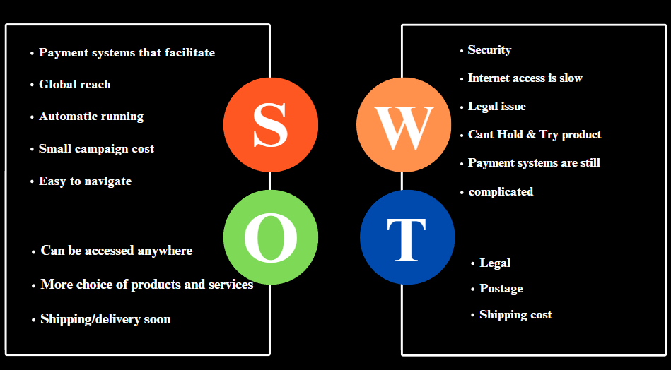
- Value Chain
Regarding Lazada's value chain, the main activities can be listed as follows:
Inbound logistics: Including managing the import of goods from suppliers into Lazada's warehouse.
Operations: Includes Lazada's internal operations to process orders, manage warehouses, and ensure sufficient product supply to meet customer needs.
Outbound logistics: This is the process of transporting goods from Lazada's warehouse to customers after they place an order.
Sales/marketing: Involves advertising and marketing products to attract customers and increase sales.
Service customer: Including providing after-sales customer support services such as user manuals, technical support, returns and complaints processing.

If you must choose the 2 most important processes out of the above five for Lazada, we will choose:
- Operations: because operations and goods management are core to ensuring Lazada provides diverse and quality products to customers.
- Service customer: Providing after-sales customer support services plays an important role in maintaining and strengthening customer relationships, while helping to create trust and loyalty from customers.
Operation Process:
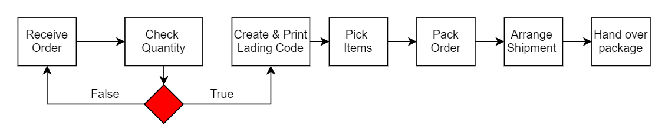

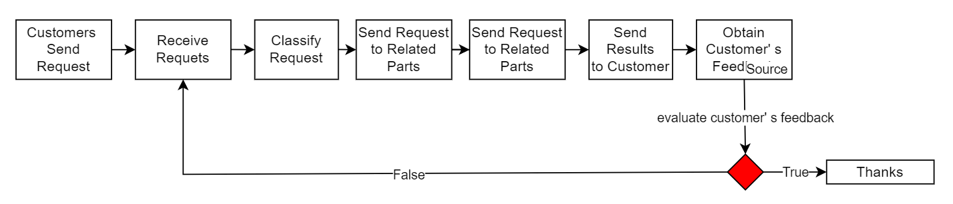
Customer Service Process:

- Business process
Key business processes in selling on an e-commerce platform like Lazada may include:
- Ordering process.
- Return process.
- Employee management process.
- Customer data management process.
- Customer feedback process.
- Inventory management process.

The "Customer Feedback" process is extremely important in building a business's competitive and differentiation strategy. Understanding and quickly responding to customer requests and feedback not only helps increase customer satisfaction but also helps improve service and product quality, from which they will have the opportunity to:
- Build close relationships with customers: Quick and positive feedback from Lazada helps create trust and loyalty from customers.
-Grasp the needs and desires of customers: By listening to customer feedback, Lazada can better understand what customers expect and thereby provide suitable products/services.
-Optimize product/service delivery process: Customer feedback helps Lazada identify the strengths and weaknesses of the service, thereby continuously improving and developing.
Business Process of Customer Feedback:
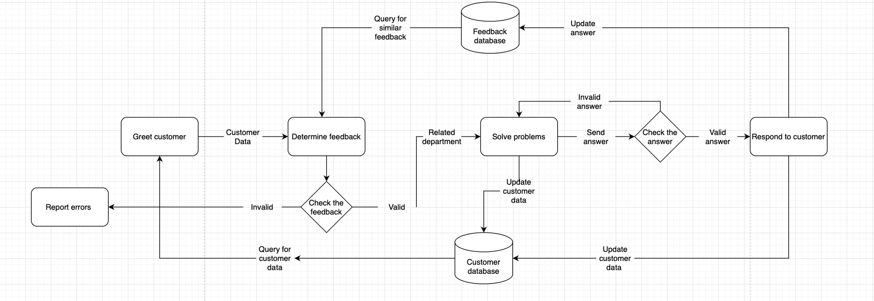
- Analyze Information System
Hardware:
- End devices: Customers interact with Lazada's IS through a variety of electronic devices that provide flexibility and accessibility. Lazada needs to be compatible with many different devices and operating systems to serve a diverse user base.
- Storage devices: Lazada has multiples high-capacity storage solutions such as:
- Hard drive (HDD) for storing large amounts of data.
- Solid state drive (SSD) for faster access to frequently used data
- Hardware security:
- Lazada uses many security hardware tools such as:
- Firewall to filter incoming and outgoing traffic, blocking potential network threats.
- Intrusion detection and prevention system (IDS/IPS) to monitor suspicious activity and prevent cyber-attacks.
- Data encryption solution to protect sensitive data both in storage and in transit.
Software:
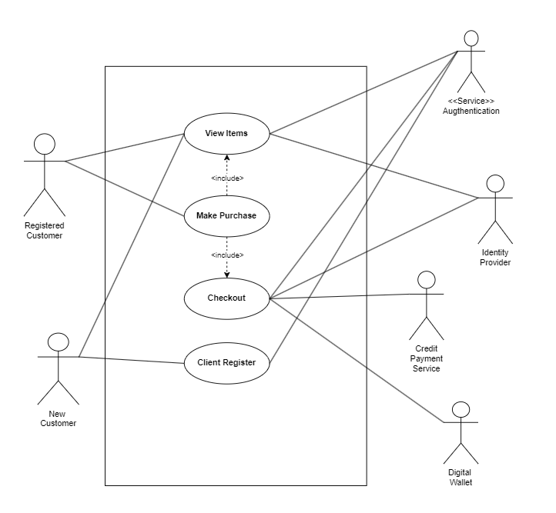
Human: People at Lazada are not only employees, but also enthusiasts, with in-depth knowledge and the ability to adapt to the changes of the times. They are the ones who build and maintain the system, ensuring that all transactions take place smoothly and securely.

Process: To make a difference, the "Customer Reply" process highlights Lazada's competitive strategy, which is also the key to building sustainable relationships with customers. By listening and responding quickly, Lazada can create trust, understand customer needs and optimize the product/service delivery process. This helps improve service quality and provide a good customer experience.

Data: In the process of using the website/mobile application and providing services, Lazada may collect the following personal data: Identity data, Contact data, Account data, Transaction data, Technical data, Profile data, Usage data, Location data, Biometric data, Marketing and communications data. Lazada is committed to protecting customer privacy, complying with data protection regulations, and ensuring that all information is used securely and transparently.

Which components contribute most to competitive strategy?

In our view, data will be the most important thing in the information system because it is the foundation of all activities in the information system. It includes information about customers, products, transactions, processes, and many other aspects. Data helps shape decisions, predict trends, and generate valuable information. The ability to collect, store, process and secure data determines the performance and success of an information system.

VI. Suggestion
Suggestion 1: Lazada can leverage VR and AR technology to create a more interactive and engaging shopping experience. Customers can try on products directly, even "wear" the items on themselves through the app.
-Impact on users: Customers will have a more enjoyable shopping experience, helping them be more confident in choosing products.
-Influence on Lazada's strategy: Integrating VR and AR helps Lazada create a difference and attract customers.
Suggestion 2: Lazada can research and deploy new payment methods: LazadaPay.
-Impact on users: Customers will experience faster, safer, and more convenient payments.
-Influence on Lazada's strategy: An effective payment system helps Lazada create trust and attract customers.

REFERENCE
- Lê Mỹ, “Tổng doanh thu trên 5 sàn thương mại điện tử Việt Nam tăng 54,3% trong năm 2023”
- Ánh Dương, “CEO Lazada VN: "Chúng tôi mong muốn giúp mọi người kinh doanh dễ dàng ở tất cả mọi nơi"

